**FAKULTAS HUKUM**

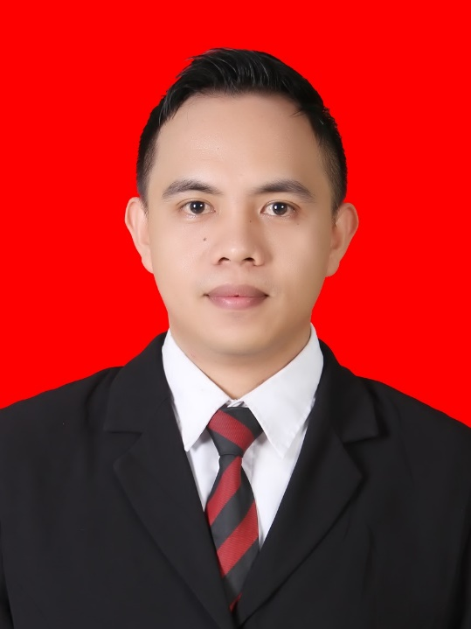

Dr. Julianto Jover Jotam Kalalo, S.H., M.H

**D E K A N**

|  |  |
| --- | --- |
| **C:\xampp\htdocs\PROJECT\BUKU WISUDA\FAKULTAS\06. HUKUM\WADEK.png** | **D:\xampp\htdocs\sipy\sistem\img\def.png** |
| Ruloff Fabian Yohanis Waas, S.H., M.H | Maria Magdalena Ndiken |
| **WAKIL DEKAN** | **KEPALA SUB BAGIAN TATA USAHA** |